Saturday, June 12, 2022
3D, Is it Worth It?

Dr. Joseph Kisslo, MD, FASE gave a history of the advances that the group at Duke University have developed over the years along with their Biomedical Engineering team:
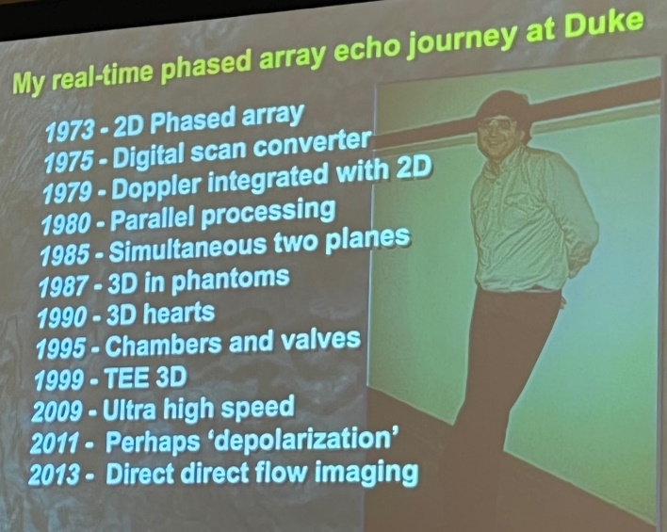
Dr Kisslo stated that all EF measurements should be by 3D because of the reproducibility and that current 3D techniques are a step along the way to future advances.
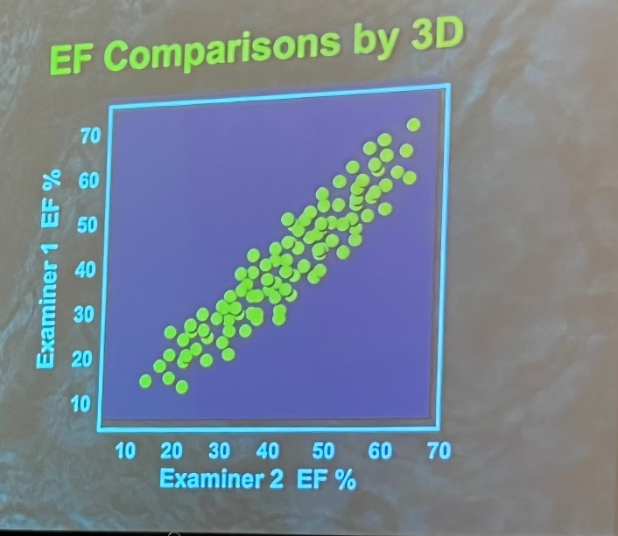
Megan Yamat, RDCS, RCS, ACS, FASE from the University of Chicago showed several case studies of tricuspid valve coaptation abnormalities which were clarified by the use of 3D. She also demonstrated remarkable differences in flow between inspiration and expiration. Dr. Kisslos commented that every other modality has the patient hold their breath and that should be standard in Echo for the purposes of consistency.
Future directions were discussed by Wendy Tsang,MD including various types of 3D rendering such as Transillumination, Glass views, stereo glasses, holographic display, stereo monitor, augmented reality, virtual reality and fusion imaging. The potential benefits are personalized pre-procedure assessment and planning and 4 chamber quantification.
