ASE 2022 Friday, June 10, 2022

From POCUS (Point of Care Ultrasound)/CCE (Critical Care Echo) SIG (Specialty Interest Group) to CCE Council: A Transformative Intersocietal Collaboration
This Session discussed the following topics:
- History of the POCUS/CCE Specialty Interest Group – Arthur Labovitz, MD, FASE
  - “Everyone should be able to do an echo where and when it is needed” with the proper training!
  - Growth of POCUS Echoes are exponential
  - 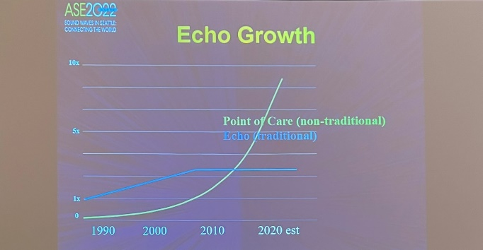
  - ASE and American College of Emergency Physicians produced a Consensus Statement
  - Certification Exam is formulated and first given in 2018 – to date over 1000 have taken and passed the Exam
  - 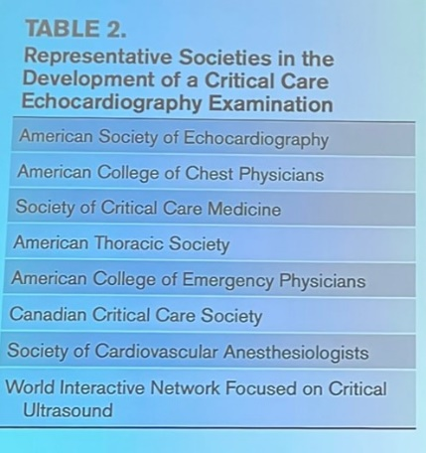
- The Value of Intersocietal Collaboration Through POCUS and CCE – Nova Panebianco, MD, MPH
  - POCUSalliance.com
  - Institutional collaboration prepared site for Covid response in novel ways, ie. Minimal patient contact, limited PPE, etc.
  - https://www.onlinejase.com/article/S0894-7317(20)30774-4/pdf
  - 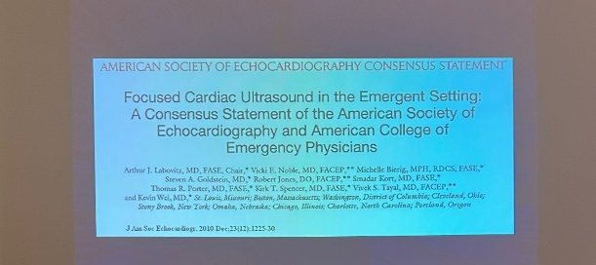
  - CCE uses such as lung ultrasound can offer Cardiologists additional information, especially in heart failure patients
- Understanding Non-Cardiology POCUS/CCE Practitioners – Smadar Kort, MD, FACC, FASE
  - Emergency Medicine
  - Critical Care
  - Anesthesiology
  - MSK & Procedures
  - Primary Care & Specialty Practices
- Vision for CCE Council Guidelines – Paul H. Mayo, MD
  - Creation of Guidelines defines roles of Non-Cardiology Uses
  - CCE requires expert acquisition skills, unlike for Echo Cardiologists
- The Future of POCUS and CCE in the Clinical Practice – Sharon Mulvagh, MD, FRCPC, FASE, FACC, FAHA
  - Use of POCUS in resource-limited areas throughout the world
  - Continued collaboration and expansion

